HW 4 - CONDITIONAL PROBABILITY HW NAME__________________________
- Donald, the quarterback, has 2 wide receivers. He throws to Goofy thirty plays and Goofy drops the ball 90% of the time. Donald throws to Pluto twenty plays and Pluto is able to catch the ball 70% of the time.
 | GOOFY | PLUTO | TOTAL
CAUGHT
DROPPED
TOTAL

a. What is the probability that ball was caught
by either Goofy or Pluto?

b. What is the probability that the ball was dropped
by either Goofy or Pluto?

c. Given that the ball is dropped, what is the probability
that it was passed to Pluto?

d. Given that the pass is caught, what is the probability
that it was Goofy who caught it?

e. P(caught | Goofy) f. P( dropped | Pluto)

2. A box contains three blue marbles, five red marbles, and four white marbles. If one marble is chosen at random, find:
a. P(blue | not white) b. P(not red | not white) c. P(white | not red)

d. P(red | not blue) e. P(not blue | not white) f. P(white | not blue)

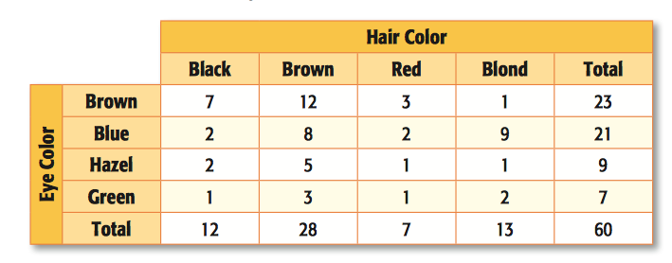
3. Given the following two way table, answer the following questions:
a. What is the probability that a person has brown hair, given that they have green eyes?
b. What is the probability that a person has green eyes, given that they have brown hair?
c. Given that a person has blue eyes, what is the probability
that a person has blonde hair?

d. What is the probability that a person has hazel eyes,
given that they do NOT have brown hair?

e. P(brown eyes | brown hair) f. P( black hair | blue eyes) g. P(blonde | not blue eyes)

4. In New York State, 48% of all teenagers own a skateboard and 39% of all teenagers own a skateboard and roller blades. What is the probability that a teenager owns roller blades given that the teenager owns a skateboard?

5. At a middle school, 18% of all students play football and basketball and 32% of all students play football. What is the probability that a student plays basketball given that the student plays football?

6. Of a class of 30 seniors, 15 enjoy watching survivor and 18 enjoy watching The Amazing Race, while 5 students watch neither show. Create a Venn diagram representing the data and find the following:

a) P (watches only Survivor) b) P (watches Amazing Race | Survivor)
c) P (watches Survivor | Amazing Race) d) P (watches Amazing Race | does not watch Survivor)
e) P (watches neither show)

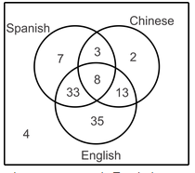
7. The international club at a school has 105 members, many of whom speak multiple languages. The most commonly spoken languages in the club are English, Spanish and Chinese. Use the Venn Diagram below to determine:
a) P (does not speak English) b) P (Spanish | English)
c) P (Spanish | Chinese) d) P (English | Chinese)
e. P(English | Spanish) f. P(Chinese | not Spanish)

8. The data from a survey of 140 students showed that 37 study music, 103 play a sport and 25 do neither. Create a Venn diagram to illustrate the data and find the following:

a) Find the probability that a student does not study music

b) Find the probability that a student studies music,
given that they do not play sports.

c) Given that a student does not study music, find the
probability that they do not play sports.

9. Compute the conditional probabilities $P\left(A | B\right)and P\left(B | A\right):$
a) P(A) = 0.7, P(B) = 0.4, P(A and B) = 0.25 b) P(A) = 0.45, P(B) = 0.8, P(A and B) = 0.3

10. Compute $P (A and B):$
c) P(A) = 0.6, P(B) = 0.18, P (A | B) = 0.3 d) P(A) = 0.2, P(B) = 0.5, P (B | A) = 0.1

