M3 GRAPHING PARABOLAS HW NAME_________________________
Sketch the graph of each function. Then state the vertex, focus, and directrix.
1. $y=\frac{1}{4}({x-3)}^{2}+2$ 2. $y=\frac{1}{8}({x+4)}^{2}+1$

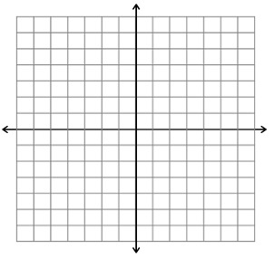

3. $y=\frac{-1}{4}({x-4)}^{2}-4$ 4. $y=\frac{-1}{16}({x+2)}^{2}-1$

5. $y=\frac{-1}{4}({x-2)}^{2}+1$ 6. $y=\frac{-1}{16}({x-2)}^{2}+4$

Find the equation of the parabola given the information provided. Show all of your work.
7. $Focus: \left(6,8\right) Directrix:y=6$ 8. $Focus: \left(2,10\right) Directrix:y=8$

9. $Focus: \left(-9,10\right) Directrix:y=8$ 10. $Focus: \left(-2,1\right) Directrix:y=-1$

11. $Focus: \left(8,5\right) Directrix:y=13$ 12. $Focus: \left(3,-8\right) Directrix:y=-6$

