AFM UNIT 4 HW 3 NAME___________________________
Find the vertical asymptotes, horizontal asymptotes, and holes for each function. DO NOT GRAPH.
1. $f\left(x\right)=\frac{x+1}{x-4}$ 2. $f\left(x\right)=\frac{2x-1}{x}$

VA: __________ VA: __________
HA: __________ HA: __________
HOLE: ________ HOLE: ________
3. $f\left(x\right)=\frac{x}{(x+5)(x-1)}$ 4. $f\left(x\right)=\frac{x^{2}-10x-11}{x+1}$

VA: __________ VA: __________
HA: __________ HA: __________
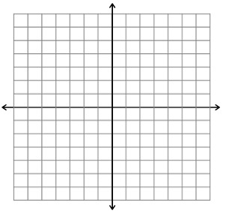
HOLE: ________ HOLE: ________
Find the vertical asymptotes, horizontal asymptotes, and holes for each function. Then graph the function.
5. $f\left(x\right)=\frac{x+2}{x-4}$

VA: __________
HA: __________
HOLE: ________

6. $f\left(x\right)=\frac{2}{x^{2}-x-20}$

VA: __________
HA: __________
HOLE: ________

7. $f\left(x\right)=\frac{4}{{(x+3)}^{2}}$

VA: __________
HA: __________
HOLE: ________

8. $f\left(x\right)=\frac{x-2}{x^{2}+6x-16}$

VA: __________
HA: __________
HOLE: ________

9. $f\left(x\right)=\frac{x^{2}-4}{x^{2}-x-6}$

VA: __________
HA: __________
HOLE: ________

