AFM HW 7 – DOT PLOTS AND STEM AND LEAF PLOTS NAME______________________
1) Below are the typing speeds (words per minute) for 22 secretarial applicants of an international cosmetic company. Graph the distribution of typing speeds as a stem and leaf plot:
68 72 91 47 52 75 63 55 65 35 69
84 45 58 61 69 22 46 55 66 71 70

2) Jorge made the accompanying stem-and-leaf plot of the weights, in pounds, of each member of the
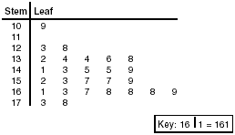
wrestling team he was coaching.
a. Are there outliers? Show your work
(hint – use your calculator to find the IQR and use
the IQR Outliers Rule from Lesson 6!)

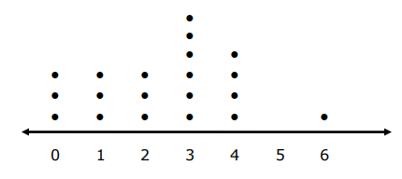
3. The students in one social studies class were asked how many brothers and sisters they each have. The dot plot here shows the results.

a. How many of the students have six siblings? b. How many of the students have no siblings?
c. How many of the students have three or more siblings?

4) The figures below show the number of vehicles that pass through a particular intersection between 4:00 pm and 5:00 pm over a two-week period:
88 92 95 82 94 83 84 85 85 90 95 82 95 81
Would a boxplot or a stemplot be a better representation of this data? Explain your choice.

5. The ages of 22 students in a karate class are given below.
11, 5, 9, 13, 8, 9, 9, 11, 10, 8, 6, 7, 12, 11, 13, 12, 7, 6, 11, 12, 10, 8
a) Make a dot plot. b) What is the spread (range) of the data?
c) What is the mode of the data? d) How many students are at least 10 years old?
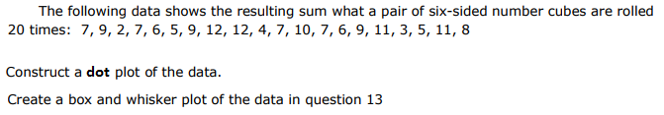
6.

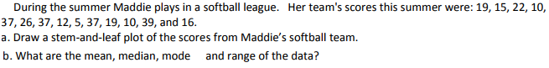
7.

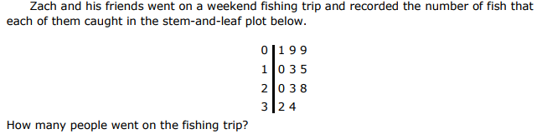
8.

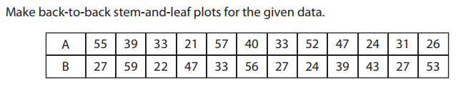
9.

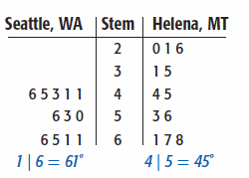
10. The back-to-back stem-and-leaf plot below shows the average monthly temperatures for Seattle, Washington, and Helena, Montana.
  - Which city has lower monthly temperatures?
Explain.

  - Which city has more varied temperatures?
  - What is the median monthly temperature for Seattle?

  - What is the median monthly temperature for Helena?

11. Display the following test scores in a back-to-back stem-and-leaf plot.
Period 1: {88, 85, 62, 66, 83, 91, 95, 89, 65, 52, 76, 63, 88, 84, 83, 90, 91, 97}
Period 5: {52, 55, 62, 89, 90, 91, 84, 83, 71, 73, 78, 64, 66, 68, 70, 75, 73, 65}

12. . Display the following test scores in a back-to-back stem-and-leaf plot.
NCAA Women’s Basketball Statistics – Overall Games Won
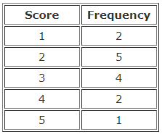
Big Ten: {5, 12, 21, 20, 11, 15, 6, 8, 18, 22, 10 Big East: {18, 21, 7, 13, 20, 25, 21, 19, 17, 11, 13, 14}

13. Find the mean, median, mode, and standard deviation given the frequency table:

14. A set of mathematics exam scores has a mean of 70 and a standard deviation of 8. A set of English exam scores has a mean of 74 and a standard deviation of 16. For which exam would a score of 78 have a higher standing? Explain your answer.
15. On a statistics exam, you have a score of 73. If the mean of the exam is 65 would you prefer the standard deviation of the scores to be 8 or 16? Why? Explain your answer thoroughly.

16. Bias exists in each of the following survey questions. Explain the source of the bias, then write a new version of the question that would be considered unbiased:
A. Many people have said that there is a need for stricter laws on the possession of dangerous weapons. Do you agree?

B. Since cigarettes are dangerous and have deadly side effects, such as cancer, wouldn't you agree that smoking should be controlled to save the lives of many?

17. Categorize the type of sampling that exists for each of the following scenarios. EXPLAIN your reasoning.
A) Using the Wake County Business Directory, number all of the businesses. Select a starting place at random, then use every 50th business listed until you have 100 businesses.
B) Group the businesses into 10 different categories: medical, shopping, retail, manufacturing, financial, construction, etc. Then select a random sample of 10 businesses from each group.
18. Determine if the following would be considered observational studies or experiments. Explain your reasoning.
A) Fifty people with clinical depression were divided into two groups. Over a 6 month period, one group was given a traditional treatment for depression while the other group was given a new drug. The people were evaluated at the end of the period to determine whether their depression had improved.

B) One hundred people who regularly work out at a gym and one hundred people who do not workout are tested for their cholesterol levels to determine whether exercise helps lower cholesterol.

19. Human pregnancies are normally distributed and last a mean average of 266 days and a standard deviation of 16 days.

a) Draw a picture of the normal curve with the pregnancy lengths for 1, 2 and 3 standard deviations above and below the mean. (Use the empirical rule)
b) What percent of pregnancies last between 218 days and 266 days?
c) Find the range between which the middle 68% of people fall.

20. The life span of a battery is normally distributed, with a mean of 2000 hours and a standard deviation of 30 hours. What percent of batteries have a life span that is more than 2065 hours? Would it be unusual for a battery to have a life span that is more than 2065 hours? Explain your reasoning. (Use your calculator)

21. Use the z – table for the following:
Find the proportions that correspond with the following z – scores:
a. z = - 1.54 b. z = 2.11 c. z = .89 d. z = – 3. 09
Find the z – scores that correspond with the following proportions:
e. bottom 15% f. top 35% g. top 7% h. bottom 45%

22. Use the z – table for the following:

Heights of kindergarten children are normally distributed with a mean of 40 and a standard deviation of 6.
A. What percent of kindergarten children are more than 4 ft tall?
B. What percent of kindergarten children are shorter C. % between 3 ft and 4.5 ft tall?
than 29 inches?
D. If 1000 kindergarten children are selected at random, F. If 1000 kindergarten children are selected at
how many will be less than 43 inches tall? How many will be more than 45 in tall?

23. Bias exists in the following scenarios. EXPLAIN the source of the bias.
A. A company makes products typically used by the elderly. The company manager provides samples of various products to residents of the retirement home where his mother lives. The residents use the products for several weeks then complete a survey giving their opinions of the company’s products
B. The school board is interested in taxpayers’ opinions on cutting funds for fine arts. They decide to ask parents since they would have an interest in school funding. A school board member attends a local high school chorus concert and interviews several parents as they are leaving the concert.
C. The Republican Party send out a survey to 500 registered Republicans in 3 states in the Northeast to determine the issues that the Republican Party should focus on for the next election.
D. A television rating service is interested in finding out what shows are being watched most often during prime time viewing hours. To obtain a sample to households, the service dials numbers taken at random from a phone book.
E. A clothing company wants to know what color leggings teenagers will buy. The company decides to spend one day in the junior departments of five randomly selected stores in randomly selected cities and ask every teenager who enters what color leggings they buy.

24. A student has taken four math tests in AFM and his scores are 67, 62, 74, and 68. If there is one test left, what score would this student need to get on the last test in order to end the class with an average of a 70?

25. A student has taken four math tests in AFM and his average on those tests is an 82. If this student makes a 70 on the fifth test, what is his new average?

26. The data below represents the number of desks on each floor of Texter Corporate.
54,60,65,66,67,69,70,72,73,75,7654,60,65,66,67,69,70,72,73,75,76
Construct a box plot to represent the data.

