**Math III Final Exam**

**Multiple Choice**

*Identify the choice that best completes the statement or answers the question.*

____ 1. What is the correct factorization of the polynomial below?



|  |  |  |  |
| --- | --- | --- | --- |
| a. | *16(2b - 3)(2b - 3)* | c. | *16(2b + 32)(2b - 3)* |
| b. | *16(4b - 9)* | d. | *(16b - 12)(4b + 12)* |

____ 2. Which of the following is a factor of ?

|  |  |  |  |
| --- | --- | --- | --- |
| a. | *x +* 4 | c. | *x +* 2 |
| b. | *x -* 2 | d. | *x -* 4 |

____ 3. What are the zeroes of the function:  ?

|  |  |  |  |
| --- | --- | --- | --- |
| a. |  | c. |  |
| b. |  | d. |  |

____ 4. Divide: 

|  |  |  |  |
| --- | --- | --- | --- |
| a. |  | c. |  |
| b. |  | d. |  |

____ 5. Simplify: 

|  |  |  |  |
| --- | --- | --- | --- |
| a. |  | c. |  |
| b. |  | d. |  |

____ 6. Two functions are defined as  and . Which of these tables can be used to find the solution of the equation *f(x)=g(x)*? Write the solution

|  |  |  |  |
| --- | --- | --- | --- |
| a. | Solutions: 4 and 6 | c. | Solutions: 1 and 3 |
| b. | Solutions: 4 and 6 | d. | Solutions: 1 and 3 |

____ 7. In order to gain popularity among high school students, Pizza Extreme plans to offer a special promotion for the month of February. If you show a student ID, the cost of a large pizza (in dollars) at Pizza Extreme is a function of time and can be described as:

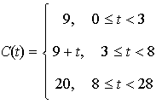

where *C(t)* is the cost of the pizza and *t* is the day of the month. What is the cost of the pizza on the 8th day of the month?

|  |  |  |  |
| --- | --- | --- | --- |
| a. | $8 | c. | $17 |
| b. | $9 | d. | $20 |

____ 8. Alicia is given $500 for her birthday and puts it in a savings account so that it will earn interest. The amount of money in the account is given by the function below, where *A* represents the amount, and *t* represents the time in years.

**

If D represents the domain, and R represents the range, which description identifies the domain and range of *A(t)*?

|  |  |  |  |
| --- | --- | --- | --- |
| a. | D: all real numbers; R: all real numbers | c. | D: (0. 500); R: All real numbers |
| b. | D: (500, ); R: (0, ) | d. | D: (0, ); R:(500, ) |

____ 9. A function has its relative maximum at *x = 1* and an absolute minimum at *x = 3.* The function is increasing in the interval -1 to 1. Which of these graphs best represents the function?

|  |  |  |  |
| --- | --- | --- | --- |
| a. |  | c. |  |
| b. |  | d. |  |

____ 10. Find the zeroes of . Then graph the equation.

|  |  |  |  |
| --- | --- | --- | --- |
| a. | 3, 2, –3 | c. | 3, 2 |
| b. | 0, –3, –2 | d. | 0, 3, 2 |

____ 11. Find the inverse of **.

|  |  |  |  |
| --- | --- | --- | --- |
| a. |  | c. |  |
| b. |  | d. |  |

____ 12. A runner, a bicycle, and a train are leaving from the same point at *x = 0* and are headed in the same direction. There are 3 functions to show the distance covered *(y)*. There is a linear function, a quadratic function, and an exponential function.

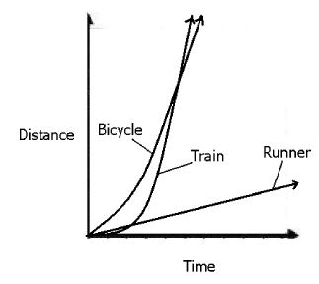

Which object’s distance is modeled by the exponential function?

|  |  |  |  |
| --- | --- | --- | --- |
| a. | the runner | c. | the train |
| b. | the bicycle | d. | They will all be equidistant from the starting point no matter how much time passes. |

____ 13. Solve for *x*: 

|  |  |  |  |
| --- | --- | --- | --- |
| a. |  | c. |  |
| b. |  | d. |  |

____ 14. The points *A, B*, and *C* lie on circle *Q* below, in which  is the diameter.

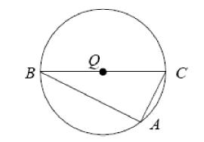

In circle *Q*, what is the measure of angle *CAB*, in degrees?

|  |  |  |  |
| --- | --- | --- | --- |
| a. | 360° | c. | 90° |
| b. | 180° | d. | 60° |

____ 15. The equation of a circle is given as . What are the center, *C*, and the radius, *r*, of the circle?

|  |  |  |  |
| --- | --- | --- | --- |
| a. |  | c. |  |
| b. |  | d. |  |

____ 16. Use the diagram below to answer the question.

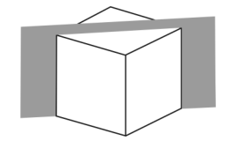

Which shape best represents the 2-dimensional shape formed by the slice made by the plane through the vertices of the cube shown?

|  |  |  |  |
| --- | --- | --- | --- |
| a. |  | c. |  |
| b. |  | d. |  |

____ 17. What solid is generated if the polygon with vertices A(3, 1), B(9, 1), and C(3, 7) is rotated about ?

|  |  |  |  |
| --- | --- | --- | --- |
| a. | cone | c. | cylinder |
| b. | prism | d. | pyramid |

____ 18. Which 2 solid figures are modeled by the light bulb shown below?



|  |  |  |  |
| --- | --- | --- | --- |
| a. | 2 spheres | c. | 1 cylinder and 1 sphere |
| b. | 1 cone and 1 sphere | d. | 1 rectangular prism and 1 sphere |

____ 19. A company specializing in building robots that clean your house has found that the average amount of time kids spend cleaning their houses is about 2 hours per week. If their sample size was 1000 randomly chosen kids and the standard deviation was 0.3 hours, what is the margin of error for a confidence interval of 95%?

|  |  |  |  |
| --- | --- | --- | --- |
| a. | 0.392 | c. | 0.039 |
| b. | 0.019 | d. | 0.185 |

____ 20. Write an equation for a polynomial that has roots -2, 3, -4.

|  |  |  |  |
| --- | --- | --- | --- |
| a. |  | c. |  |
| b. |  | d. |  |

____ 21. Simplify: 

|  |  |  |  |
| --- | --- | --- | --- |
| a. | 4(x - 2) | c. | -4(x - 2) |
| b. | x + 2 | d. | -4(x + 2) |

**Short Answer**

22. In order to gain popularity among high school students, Pizza Extreme plans to offer a special promotion for the month of February. If you show a student ID, the cost of a large pizza (in dollars) at Pizza Extreme is a function of time and can be described as:



where *C(t)* is the cost of the pizza and *t* is the day of the month. If you want to give their pizza a try, on what date(s) should you buy a large pizza in order to get the best price? Justify your answer.

23. Match each graph to one feature of the function and one context description. Place your answers in the box below.

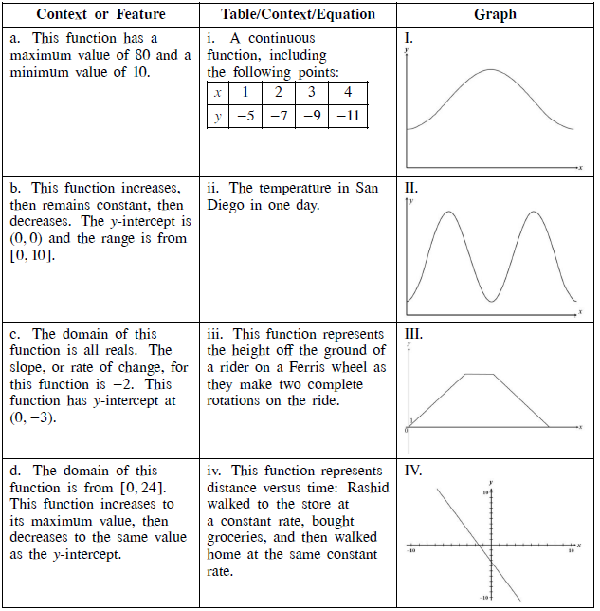

Answer box:

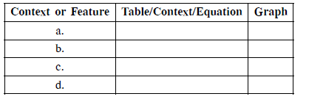

24. Use the figure below to answer the following question.

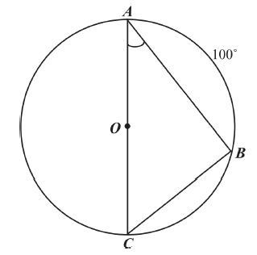

Triangle ABC is inscribed in a circle O. What is the measure of ?

25. A student interested in comparing the effect of different types of music on short-term memory conducted the following study: 80 volunteers were randomly assigned to one of two groups. The first group was given five minutes to memorize a list of words while listening to rap music. The second group was given the same task while listening to classical music. The number of words correctly recalled by each individual was then measured, and the results for the two groups were compared.

a. Is this study an experimental study or an observational study? Justify your answer.

b. In the context of this study, explain why it is important that the subjects were randomly assigned to the two experimental groups (rap music and classical music).

26. The expression (x + 1) is a factor of . What is the value of *k*? How do you know?

**Math III Final Exam**

**Answer Section**

**MULTIPLE CHOICE**

1. ANS: C PTS: 1 STA: A.SSE.2

2. ANS: D PTS: 1 STA: A.APR.2

3. ANS: A PTS: 1 STA: A.APR.3

4. ANS: A PTS: 1 STA: A.APR.6

5. ANS: D PTS: 1 STA: A.APR.7

6. ANS: C PTS: 1 STA: A.REI.11

7. ANS: D PTS: 1 STA: F.IF.2

8. ANS: D PTS: 1 STA: F.IF.4

9. ANS: A PTS: 1 STA: F.IF.7

10. ANS: D PTS: 1 STA: F.IF.7

11. ANS: A PTS: 1 STA: F.BF.4c

12. ANS: C PTS: 1 STA: F.LE.3

13. ANS: D PTS: 1 STA: F.LE.4

14. ANS: C PTS: 1 STA: G.C.2

15. ANS: B PTS: 1 STA: G.GPE.1

16. ANS: D PTS: 1 STA: G.GMD.4

17. ANS: A PTS: 1 STA: G.GMD.4

18. ANS: C PTS: 1 STA: G.MG.1

19. ANS: B PTS: 1 STA: S.IC.4

20. ANS: C PTS: 1 STA: A.APR.3

21. ANS: D PTS: 1 STA: A.APR.6

**SHORT ANSWER**

22. ANS:

February 1 or 2. On these two days, the pizza is $9. On the 3rd day the price goes up to $12

PTS: 1 STA: F.IF.2

23. ANS:

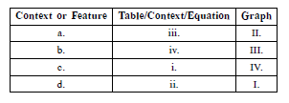

PTS: 1 STA: F.IF.9

24. ANS:

40°

PTS: 1 STA: G.C.2

25. ANS:

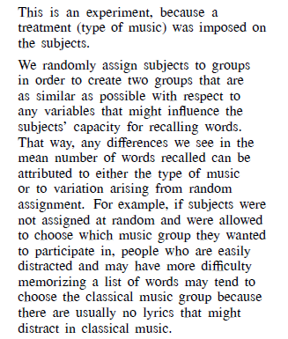

PTS: 1 STA: S.IC.3

26. ANS:

k = 4

PTS: 1 STA: A.APR.2