Name _____________________________

Homework – Systems Applications

MC900286941[1]

1. A group of 42 people go to an amusement park. The admission fee for adults is $16. The admission fee for children is $12. The group spent $568 to get into the park. How many adults and how many children were in the group?

2. The drama club at Lincoln High School sells hot chocolate and coffee at the school’s football games to make money for a special trip. At one game, they sold $200 worth of hot drinks. They need to report how many of each type of drink they sold for their club records. Macha knows that they used 295 cups that night. If hot chocolate sells for 75¢ and coffee sells for 50¢, how many of each type of hot drink did they sell?

3. At Lou has $8.60 in dimes and quarters. If he has twelve more quarters than dimes, how many dimes does he have?

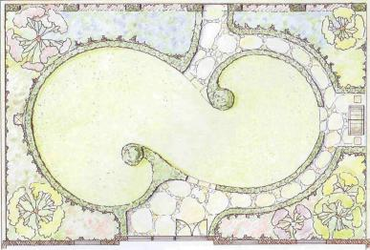

4. The length of Sally’s garden is 4 meters greater than 3 times the width. The perimeter of her garden is 72 meters. What are the dimensions of Sally’s garden?

5. At a college production of *Evita*, 400 tickets were sold. The ticket prices ere $8, $10, and $12, and the total income from ticket sales was $3700. How many tickets of each type were sold if the combined number of $8 and $10 tickets sold was 7 times the number of $12 tickets sold?

6. The sum of 3 numbers is 16. The largest number is equal to the sum of the other two, and 3 times the smallest number is 1 more than the largest. Find the three numbers.

7. Adrienne has $6000 invested among a savings account paying 3%, a time deposit paying 4%, and a bond paying 8%. She has $1000 less invested in the bond than in her savings account, and she earned a total of $260 in annual interest. What has she invested in each account?