Simulation Problems Worksheet

Describe how you would conduct one trial of a simulation model for each of the following situations.

1. Based on his history, Leon has an 80% chance of making a foul shot in a basketball game. Suppose Leon attempts 18 foul shots in a game. Describe one trial of a simulation model for Leon’s foul shot results in a game.

2. Based on her history, Mindy scores on 60% of her shots on goal in a field hockey game.
Suppose she attempts 8 shots on goal in a game. Describe one trial of a simulation model for Mindy’s shots on goal results in a game.

3. The Bumble Bees’ chance of winning a football game is 20%. Suppose they play 15 football games in a season. Describe one trial of a simulation model for their 15 game season.

4. Based on his history, Anthony has a 75% chance of making a foul shot in a basketball game. Suppose he makes 16 shots in a game. Describe one trial of a simulation model for Anthony’s foul shot results in a game.

5. A goalie saves half of the shots on goal. Suppose there were twelve shots in a game.
a) Describe how you would conduct one trial of a simulation that models the results of the shots on goal.
b) Suppose the goalie saved 2/3 of the shots on goal. Describe how you would conduct one trial of a simulation that models the results of the shots on goal.
c) How many trials should be conducted to obtain reasonable results? Use mathematics to justify your answer.

6. Carlos has two chances to get the correct answer on a multiple-choice question with three choices. Suppose he guesses. He will answer correctly on the first try $\frac{2}{3}$ of the time. If he has to try again, he has a 50% chance of getting the correct answer. Describe one trial of a simulation model for Carlos getting the correct answer on a multiple-choice question.

Review
1. In a literature class, the students are going to be randomly assigned novel to read and write a report. The randomly assigned novel comes out of the teacher’s library of 42 novels.
- In a class of 27 students, how many combinations of novels and students are possible?
- Before the books are assigned, the teacher tells the students that they will all get an A if anyone in the class can predict correctly which students are assigned which novel with the limit that each student only gets one guess. What is the probability of this occurring?
- How could this problem have been rewritten so that order does not matter?

2. A study showed that the function 𝑚(𝑡) =60log(2𝑡+4) approximates the population of mice in a building abandoned 5 years ago with t being the number of months since the building was abandoned.
- Use a table to find the population of the mice after each year. Which year showed the most growth? The least growth?
- Describe the domain and range of the function.
- How does using a logarithmic function fit the context of this problem?
- When will m(𝑡)=60? How do you know?
- Consider the graph of the function m(𝑡). What function would result by shifting the graph 3 units to the right? What would this mean in the context of this problem?
3. An investment earning 8.5 % annually can be evaluated after t years, using $A\left(t\right)=A_{n}e^{0.085t}$ a. When will a $1200 investment be valued at $1600?
b. At what rate would it double in 6 years?

4. On September 25, 2006, Laurinburg NC experienced an earthquake that registered 3.7 on the Richter scale. The Richter scale was revised in 1979 so that R, the magnitude of the earthquake, is defined by 𝑅=0.67 log(0.37𝐸) + 1.46 where E is energy in kilowatt-hours (kWh)
- How much energy was released in this earthquake?
- According to the US Energy Information Administration, for 2013 the average US home used 10,908 kWh for that year. Based on that average, how many months does a US home use an equivalent amount of energy as this earthquake?
- An Indian Ocean tsunami created on December 26, 2004 by an undersea earthquake was one of the largest earthquakes in recorded history. It measured 9.3 on the Richter scale. Based on the average energy used in a US home in a year, the energy from how many US homes is equivalent to the energy released during this earthquake? (There are approximately 123.2 million homes in 2014 in the US according to the US Census Bureau.)

5. Solve for x:
- $\log_{2}{\frac{x}{6}}=5$
- $\log_{3}{24}=x-1$
- 5 ln𝑥−3 ln𝑥 = 36
- 3𝑒^{2x} − 5 = −2

6. Solve for x using technology: $2\log_{3}\left(x-1\right)=\log_{5}{(4x^{2}-25)}$
7. Given the following piecewise function $h\left(x\right)=\left\{\begin{aligned}x^{2}, -3≤x<3 \\ 2-x, 3≤x<7\end{aligned}\right.$
- Sketch the graph and state the domain and range using interval notation.
- What is ℎ(3)? How do you know which function to use?

8. The frequency chart below shows the number of males in a college course categorized by height.

Height (inches) | Number males
51-55
56-60
61-65
66-70
71-75
76-80
81-85
- What is the shape of the distribution?
- Estimate the mean and the median.
- How might this chart and distribution be affected if the data for the females were included?
9. Each orange tree in a California grove produces 600 oranges per year if no more than 20 trees are planted per acre. For each additional tree planted per acre, the yield per tree decreases by 7 oranges.
- Describe the orange tree yield algebraically.
- Determine how many trees per acre should be planted to obtain the greatest number of oranges.

10. Write the piecewise function for the graph below.
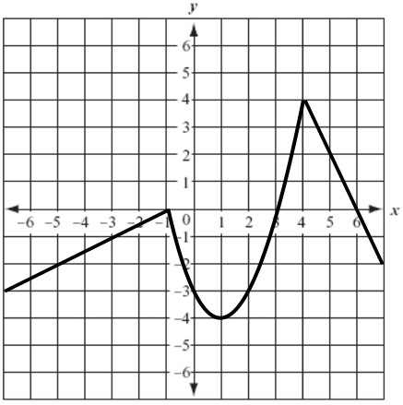
11. Using x to represent time and y to represent distance from home, create a piecewise function that represents a realistic morning exercise routine with the following criteria:
(Assume that the person is moving in a straight line away from and back to home.)
- Starts out walking from home for 5 minutes
- Jogs for the next 20 minutes
- Stops to get a drink of water for 1 minute
- Turns around and jogs back towards home for 15 minutes 5) Walks back home for 10 minutes.

