**Honors Math 3 Review - Circles**

1. Write the equation of the circle with a center at (4, 3) that passes through the point (-4, 6)

2. Write the equation of the circle with endpoints of the diameter at (3, -5) and (7, -11)

3. Find the center and radius of the circle with equation x2 + y2 – 16x + 4y – 20 = 0

4. Write the equation of the circle with a center at (-4, -7) tangent to the line y = -2.

5. Find the center and radius of the circle with equation x2 + y2 + 20x + 8y – 44 = 0

For each of the following, find x:

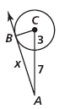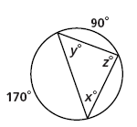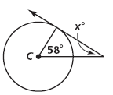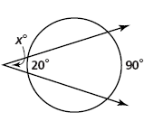

6. 7. 8. 9.

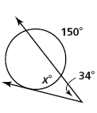

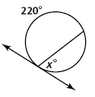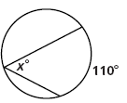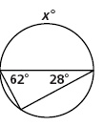

10. 11. 12. 13.

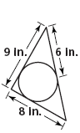

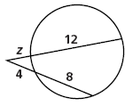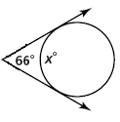

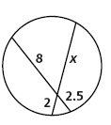14. 15. 16. 17.

x

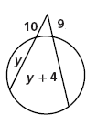

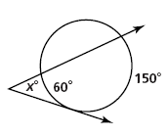

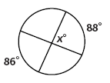18. 19. 20.

21. Find the length of arc  22. The diameter is  cm. 23.The length of arc  is  in.

Find the length of arc . Find the length of the radius.

F

E

30°

C

D

60°

A

B

6 cm

120°

24. A circle has an arc whose measure is 80° and whose length is . What is the diameter of the circle?

25. A circle has a circumference whose length is . Find the length of an arc whose central angle is .

26. Find the measure of the central angle of an arc if its length is  and the radius is 18.

27. The area of a circle is  square inches. Find the area of the sector whose central angle is .

28. The central angle of a sector is  and the area of the circle is . What is the area of the sector?

29. A circle has a radius of 12. Find the area of the sector whose central angle is .

30. Find the radius of a circle which has a sector area of  whose central angle is .

31. The central angle of a sector is  and the sector has an area of . Find the radius.

32. Find the measure of the central angle of a sector if its area is  and the radius is 6.

***Find the area of the shaded sectors:***

33. 34. 35.

90°

16 in

8 m

135°

18 m

40°

36.

120°

2 in

6 in