Name:____________________________________________________________ Honors Math 3 Unit 1 Review

Using words, describe the transformation of the parent function f(x) that will occur when graphing g(x):
1. $f\left(x\right)= \left|x\right|; g\left(x\right)= \left|x+2\right|+6$ 2. $f\left(x\right)= \left|x\right|; g\left(x\right)= -\left|3x+9\right|-5$

Graph each function. Give the domain and range for questions 4 – 8, 11, and 12.
3. $2x-y=-4$ 4. $f\left(x\right)= -2{\left(x+2\right)}^{2}-4$
5. $f\left(x\right)= -\left|2x-6\right|+5$ 6. $f\left(x\right)= \left|x+4\right|-1$
7. $f\left(x\right)= x^{2}-2x+6$ 8. $f\left(x\right)= {-2x}^{2}+4x-1$
9. $f\left(x\right)= \left\lfloor x\right\rfloor +1$ 10. $f\left(x\right)= -\left\lceil \frac{1}{2}x\right\rceil$
11. $f\left(x\right)= \left\{\begin{aligned}-2x+1; x<-2 \\ -\left|x\right|+2; x≥-2\end{aligned}\right.$ 12. $f\left(x\right)= \left\{\begin{aligned}-({x+1)}^{2}; x≤-4 \\ x; -4<x<2 \\ -\left|2x\right|; x≥2\end{aligned}\right.$
Evaluate the functions at the following values:
$13. f\left(x\right)=\left\{\begin{aligned}x^{2}+2; x≤-1 \\ x-3; -1<x≤4 \\ -\left|2x+2\right|; x>4\end{aligned}\right.$ a) f (- 4) = _______ b) f (2) = ________ c) f (6) =________

14. $f\left(x\right)= \left\lceil x-2\right\rceil$ a) f (- 4.2) = _______ b) f (0.1) = ________ c) f (6.5) =________

Solve:
15. $2\left\lfloor x+3\right\rfloor +4=12$ 16. $6-\left\lceil 2x-4\right\rceil =12$

Determine if the following are inverses – if not, give the correct inverse:
17. $f\left(x\right)=3x^{2}-4$ 18. $f\left(x\right)=\frac{1}{4}x+\frac{2}{3}$
$g\left(x\right)=±\sqrt{\frac{x+4}{3}}$ $g\left(x\right)=4x-8$
Evaluate the following if $f\left(x\right)=2x-6$, $g\left(x\right)=\frac{1}{2}x^{2}+x$, and $h\left(x\right)=\left|2x\right|-3$.
19. $f(g\left(-3\right))$ 20. $f(h\left(4\right))$ 21. $h(f\left(\frac{-3}{2}\right))$
22. $f∘g(4)$ 23. $h∘h(-3)$ 24. $g∘f(x-3)$

25. Residential wastewater rates are based on a monthly customer charge of $4 plus $1.75 per 1000 gallons of water used. Write a step function to represent the monthly cost, c, in dollars for x gallons of water used.

Write the equations of the functions shown below:
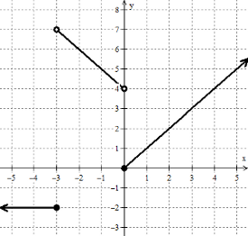
26. 27.

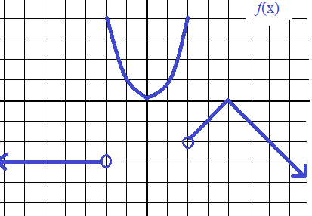
28.

