AFM UNIT 2 HW 3 NAME____________________
I. State the domain of the following (find algebraically):
1. $y=5x$ 2. $y=2\sqrt{x+2}-3$ 3. $y=\frac{2x}{4x-2}$ 4. $y=\frac{1}{\sqrt{2x+6}}$

II. State the range of the following:
5. $y=1-2x^{2}$ 6. $y=-\sqrt{x+4}$ 7. $y=x^{3}-3x+2$ 8. $y=x^{2}+6$

9. $y=-\left|x-1\right|$ 10. $y=2\sqrt{x-3}$ 11. $y=2x-3$ 12. $y=\left|x+3\right|+2$

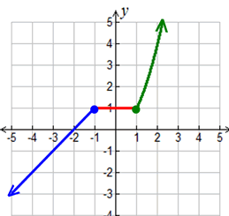
III. State the intervals on which the graph is increasing, decreasing, and constant.
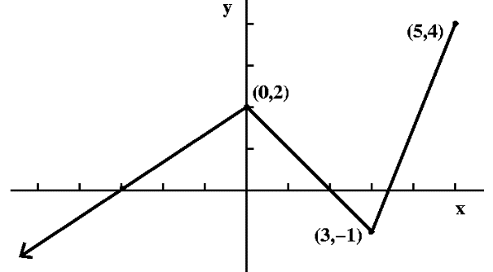
13. 14.

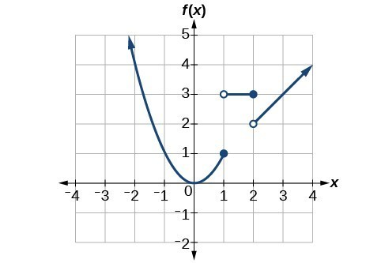
15.

IV. Evaluate the given piecewise functions:
16. $f\left(x\right)=\left\{\begin{aligned}-3x-4, x≤-2 \\ x+1, x>-2\end{aligned}\right.$ 17. $f\left(x\right)=\left\{\begin{aligned}-x+3, x≤-1 \\ 4, -1<x≤1 \\ x^{2}-1, x>1\end{aligned}\right.$

a. $f\left(6\right)=$ b. $f\left(-2\right)=$ a. $f\left(1\right)=$ b. $f\left(-4\right)=$

c. $f\left(0\right)=$ d. $f\left(4\right)=$ c. $f\left(0\right)=$ d. $f\left(8\right)=$

