HW 4 – NORMAL DISTRIBUTION BY HAND NAME___________________________
Convert the following z – scores into proportions:
1. z = – 1.25 2. Z = 3.01 3. Z = – 0.82 4. Z = 0.07 5. Z = – 3.39

Convert the following proportions into z – scores:
6. bottom 30% 7. Top 13% 8. Bottom 5% 9. Top 33% 10. Bottom 18%

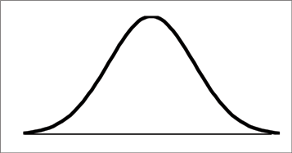
11. The results of an AFM test are normally distributed with a mean of 74 and a standard deviation of 8. Find the following:
a. Draw a normal distribution curve. Fill in your percents based on the empirical rule.
b. Find the % of students who made below a 60.

c. Find the % of students who made over a 92 d. Find the % of students who made between a 70 and 79

e. If 65 students took the test, how many made above an 80? F. What grade do you need to be in the top 20% of the class?

G. What is the max grade needed to fall in the bottom 25%? H. What grade do you need to be in the top 5%?

12. The average number of times a person has been on a plane is 16 with a st. dev. of 3. Find the following.
a. Draw a normal distribution curve. Fill in your percents based on the empirical rule.
b. Find the % of people who have been on a plan less than 9 times.

c. % of people who have been on a plane over 22 times. D. % between 8 and 15 times on a plane.

e. % between 12 and 18 times on a plane. F. If this was from a survey of FVHS seniors, how many seniors have been on a plane more than 20 times?

G. Find max # of times to be in bottom 10% H. Find min # of times to be in top 18%

I. % of people less than 5 times on a plane J. % of people more than 19 times on a plane

K. Min # of times to be in top 35% L. Find max # of times to be in bottom 5%

