AFM Probability Review Sheet Name______________________________
For questions 1-8, one card is selected from a deck of cards. Find the following:
- P(black card) 5. P(diamond or a even number card)

- P(spade or a face card) 6. odds against picking a spade

- odds in favor of picking a face card 7. P(a face card or a number greater than 5)

- odds against picking a queen 8. P(a queen or a red card)

A box contains 10 jellybeans: 4 red, 3 blue, 2 yellow and 1 orange. You are to pick TWO jellybeans out of the box. Find the probability of selecting:

with replacement: 9. a red, then a yellow 10. orange and red 11. at least one blue

without replacement: 12. red and yellow 13. two blue 14. a blue and a yellow

Pick THREE jellybeans from the box above without replacement:
- red and 2 yellow 16. at least one yellow 17. an orange, then yellow, then blue

18. Mrs. Murphy gives a multiple-choice test with 15 questions. Each question has 5 choices. Find the probability of getting exactly 8 questions correct.

19. Mrs. Barber gives a true-false test with 10 questions. Find the probability of getting at least 7 right.

20. For the test in question #18, find the probability of getting less than 6 questions wrong.

21. You pay $2 to play a game. Four coins are flipped. If you get all HEADS, then you win $5, and otherwise you lose. What is the expected value for you? What is the fair price to roll?

22. Six thousand raffle tickets are sold for $5 each. There is a grand prize of $2500. If Ronald buys one ticket, what is the expected value?

23. Ms. Norris chooses 7 out of her 36 students to receive a free homework pass. What are the odds of receiving a free homework pass?

24. The odds AGAINST catching Bieber Fever are 8:4. What is the probability that you WILL catch Bieber Fever?

25. Christina is the star player of the Duke soccer team. In the past year, she has scored 80% of her shots on goal. If she shoots the ball 11 times during the championship game, what is the probability that she will score AT LEAST 4 goals?

 | Pass | Fail | Total
Men | 50 | 30 | 80
Women | 40 | 20 | 60
Total | 90 | 50 | 140
Use the chart to answer questions 26-30. You select one person at random who has taken the written drivers test.
26. P(woman) 27. P(fail)

28. P(woman | passed) 29. P(failure | man)

30. Are the events “being a man” and “passing” independent events?

Of 100 students surveyed, 58 said that they enjoy watching The Voice and 67 said they like watching Dancing with the Stars (DWS), while 12 students said they don’t watch either show. Find the following:

31. P(the Voice | not DWS) 32. P(neither | not the Voice)

33. P(DWS | the Voice) 34. P(the Voice | DWS)

35. Are liking Dancing With the Stars and The Voice independent events?

A total of 109 deer were surveyed about activities that they enjoy. The results are summarized in the Venn diagram below. If one deer was selected at random, find the probability that the deer
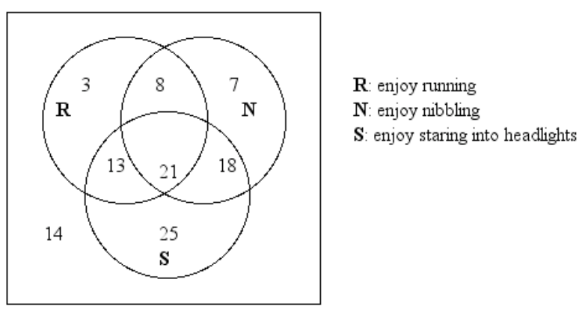
36. $P(ONLY enjoys nibbling)$

37. $P\left(does not enjoy running\right)$

38. $P(enjoy nibbling\left|enjoy running\right.$)

$$39. P(enjoy running\left|enjoy staring into headlights)\right.$$

$40. P(enjoy staring into headlights\left|not nibbling\right.$) 41. $P(Not nibbling\left|not staring)\right.$

A company manufactures backpacks in three colors: orange, purple, and polka dot. Since orange is so popular, 50% of all backpacks made are orange; 20% are purple, and 30% are polka dot. An employee tests the zippers on randomly selected backpacks to make sure they work properly. On a selected week, 10% of the orange zippers did not work, while 12% of the purple zippers and 14% of the polka dot zippers were defective. Find the following:

42. make a tree diagram to represent the data

43. P(a zipper works properly) 44. P (polka dot | zipper works)

45. P(orange | zipper fails) 46. P (purple | zipper fails)

47. One thousand lottery tickets are sold for $1 each. One grand prize of $500 and two consolation prizes of $100 will be awarded. Find the expected value and fair price of a ticket.

48. In complete sentences, explain the difference between an event having a probability of 1 and an event having odds of 1.

49. Choose 2 cards from a deck of cards WITHOUT REPLACEMENT:
a. P(red card and a black number card) b. P(at least 1 ace) c. P (2 jacks)

_________________ ________________ ____________________

50. Which of the following has a better chance of success, a probability of $\frac{2}{5}$ or odds of $\frac{2}{5}$ ? Explain in complete sentences.

