**AFM – Circular Trig Review Sheet Name________________________**

*\*This portion of the test will be CALCULATOR* ***ACTIVE****\**

**Find the degree measure of the angle for the rotation. Sketch each angle in standard position.**

1. rotations, counterclockwise 2. $\frac{3}{4}$ rotation, clockwise 3. $\frac{2}{3}$ rotation, clockwise

**Name three angles, two positive and one negative, that are coterminal with the given angle.**

4. 529° 5. 6.

**For each of the following angles, find a coterminal angle with measure θ such that**  or

7. 536° 8. 9.

**Express the angle in radians or degrees, whichever is necessary.**

10. 370° 11. 12.

13. 14. 400° 15. $-$ 65°

**Find the radian measure of the resulting angle, in standard position, after the given number of rotations.**

16. , 2 clockwise 17. $θ=\frac{3π}{4}$, 2.5 counterclockwise

**Given the point that lies on the terminal side of an angle θ, find the six trigonometric functions.**

18. ( - 8, 6) 19. ( - 2, - 7)

**Given the following information, find the other missing trigonometric functions.**

20. and θ is in QIII 21. $cosθ=-\frac{8}{17}$ and θ is in Q II

**Given the following information, find the trigonometric functions.**

22. Given that and cos , find

23. Given that cos $θ=-\frac{5}{6}$ and sin $θ<0,$ find sin $θ and\tan{θ}$.

*\*This portion of the test will be CALCULATOR* ***INACTIVE****\**

***Name the quadrant(s) in which $θ$ lies if:***

24. 25. 26.

27. 28. 29.

**Use your unit circle to** **fill in the chart.**

|  |  |  |  |  |  |  |
| --- | --- | --- | --- | --- | --- | --- |
|  |  |  |  |  |  |  |
| **30. 0**° |  |  |  |  |  |  |
| **31. $\frac{π}{2}$** |  |  |  |  |  |  |
| **32. 135**° |  |  |  |  |  |  |
| **33. $\frac{4π}{3}$** |  |  |  |  |  |  |
| **34. 330**° |  |  |  |  |  |  |
| **35. 300**° |  |  |  |  |  |  |

**Describe the changes from the parent function. Graph the following on the interval **

36. 37.  38.  39. $y=-2\cos{ϑ}-3$

**Write the equation of the function given the graph.**

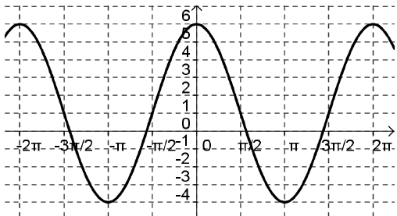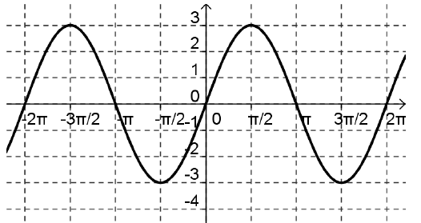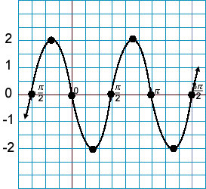40. 41. 42.

**Simplify the following identities.**

43. 44. 45. 46. $\frac{secϑ-cosϑ}{sinϑ}$

**Verify the following identities.**

47. 48.

49. 50.